Document last edited: 5/10/2017 by Robert Rainey

Using TwinCAT 2 to communicate with the ATI EtherCAT F/T Sensor:
- Copy the ESI (“EtherCAT Slave Information”) .xml file into TwinCAT’s ESI folder, usually “C:\TwinCAT\Io\EtherCAT”
- When starting TwinCAT for the first time, you must install the EtherCAT driver on the network card you will use with TwinCAT:
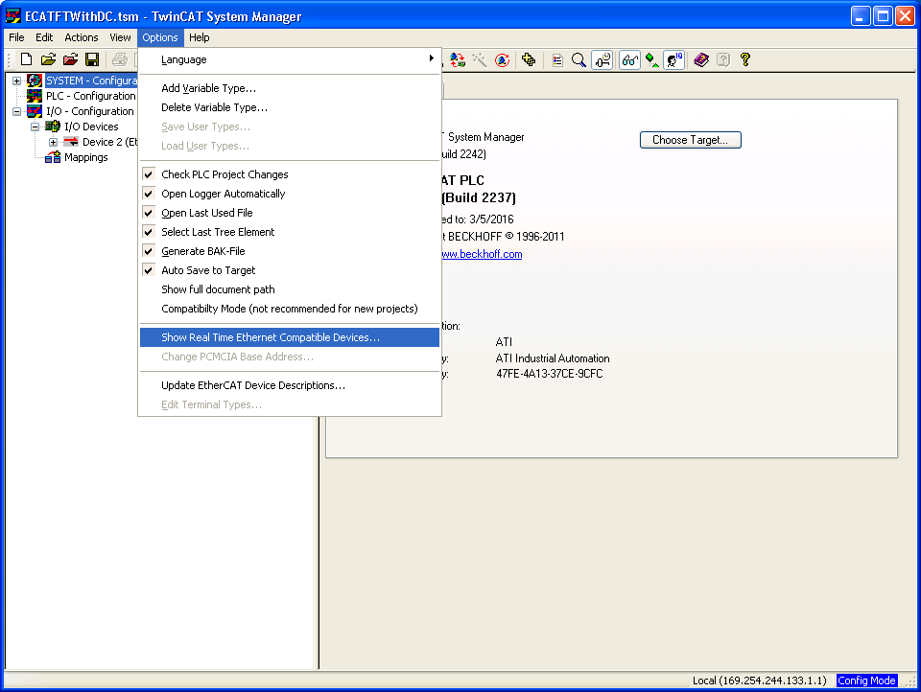
- Look in the list of “Compatible Devices” for the NIC you will use to connect to the EtherCAT F/T. If you do not have a Compatible Device, you may still be able to install the driver on one of the “Incompatible Devices,” but you will not be able to make TwinCAT go into real-time mode, and you may also have difficulty entering Free Run mode. Select the device you wish to install the driver on and click “Install” (note: this screenshot doesn’t show any available compatible devices because the system it was taken on already has the driver installed):
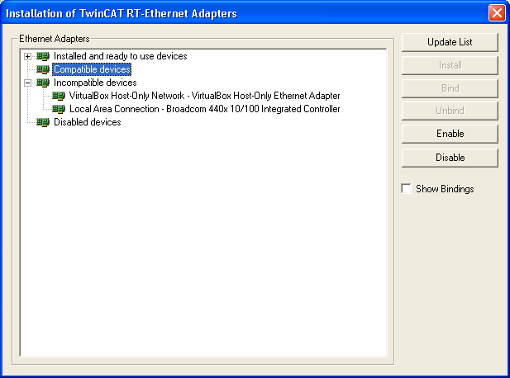

- After installing the driver, TwinCAT will show the device as “Installed and ready to use.”
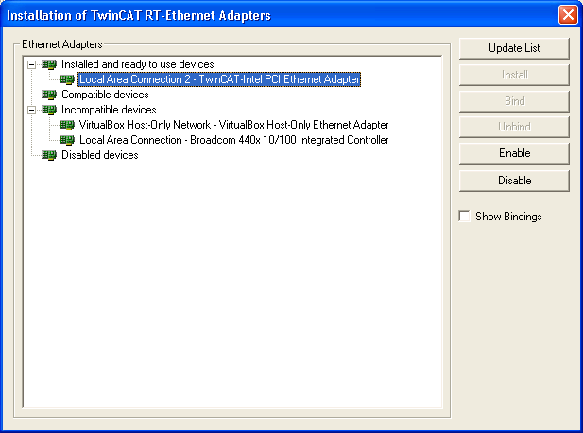

- Connect the EtherCAT F/T sensor to the NIC you have installed the driver on, and apply power to the sensor.
- Right click “I/O Devices” and select “Scan Devices”
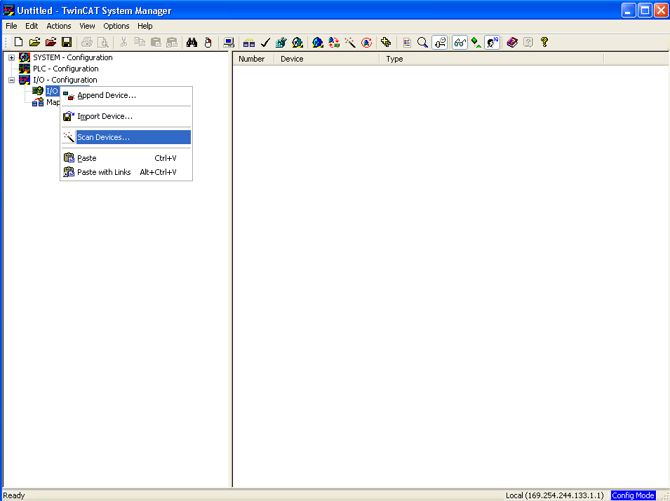

- Click OK on this notification:
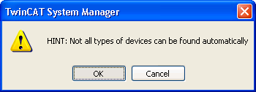
- If the EtherCAT F/T is found, the adapter will be shown as an “EtherCAT” device. Click OK.

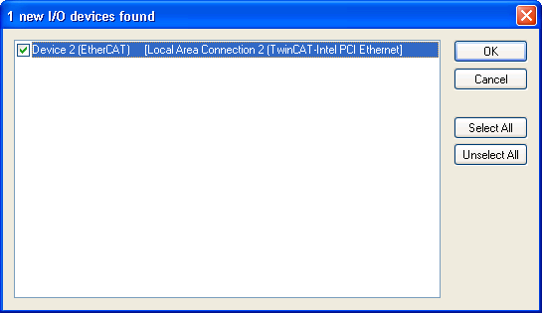
  - Note: If the adapter is not labeled “EtherCAT,” for example if the adapter is labeled as “RT-Ethernet,” the sensor may not be communicating or powered up, and you will not be able to communicate until you fix this issue.
- Click “Yes” when asked to scan for boxes. “Boxes” is the term for EtherCAT modules such as the EtherCAT F/T Sensor.
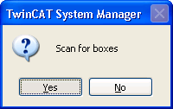

- You can activate Free Run now wait until later.
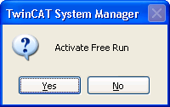
- The EtherCAT F/T Sensor should show up in the list of boxes. You can click on it and select the “CoE – Online” tab to explore the dictionary objects. Several dictionary objects are standard EtherCAT objects and are not covered in the ATI manual. All ATI-specific objects, such as the firmware version object 0x2090, are covered in the ATI manual.
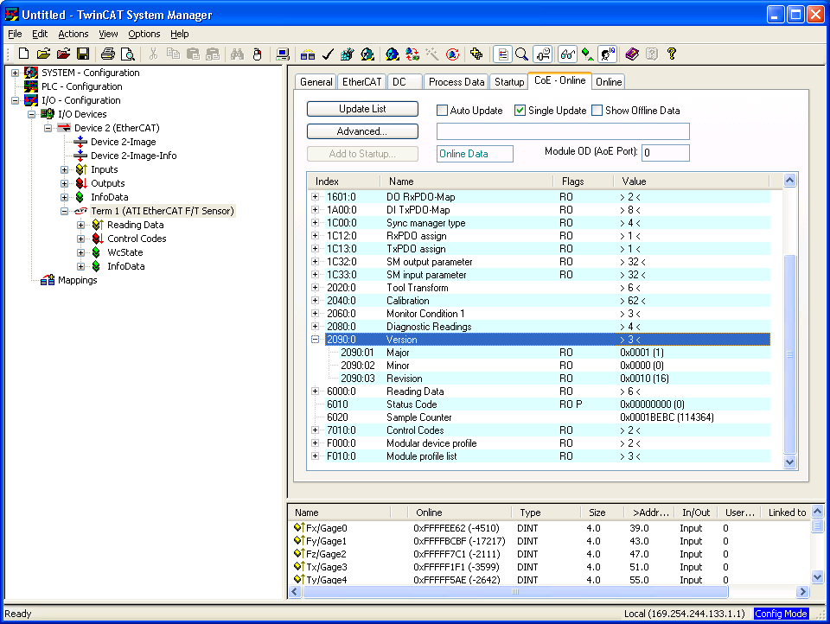
- To enter free run mode, click the Free Run icon in the toolbar at the top of the window. When in free-run mode, you can expand the data view and see the F/T count values changing.
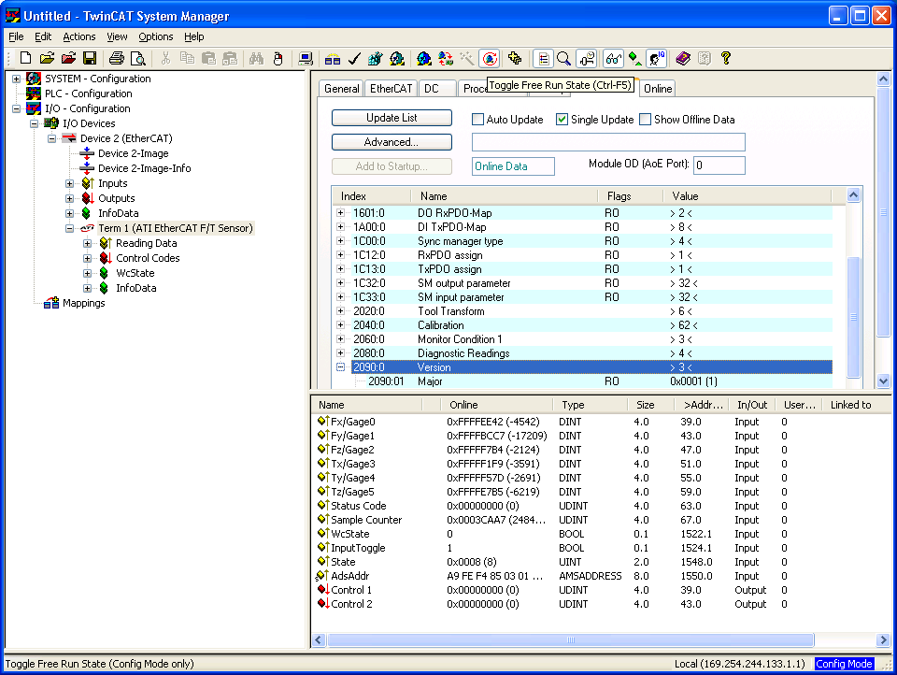
  - Note: Free Run mode is not “Real Time,” it is simply continuously querying the data at regular intervals based on the PC clock. Configuring TwinCAT for Real Time mode is not covered in this document. If you have questions about configuring TwinCAT for real time mode, consult Beckhoff for technical support and licensing details.

- To perform actions such as biasing the sensor in Free Run mode, right click the appropriate control code and select “Online Write.” See the ATI manual for description of the functions of the control codes.
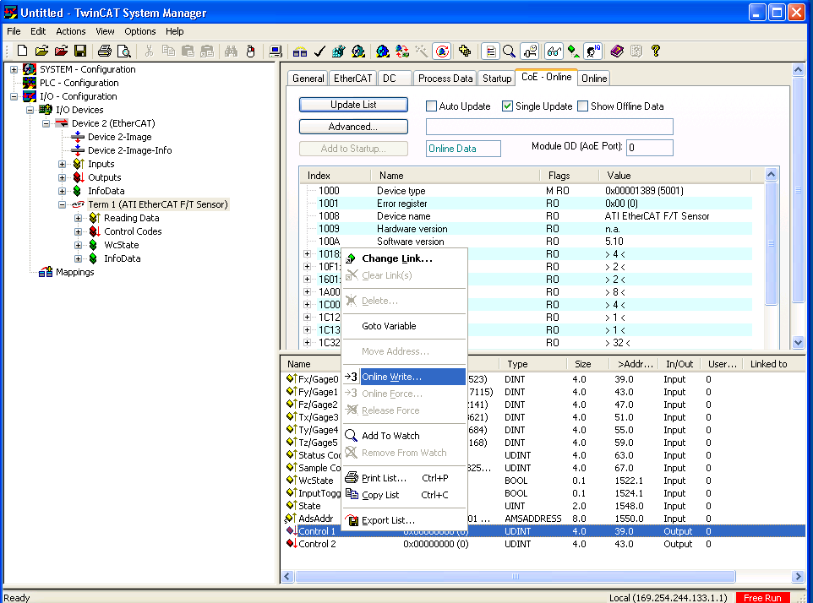

- For example, to bias the sensor, set bit 0 of Control 1.
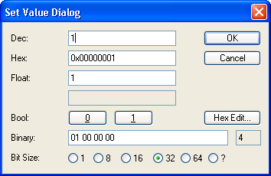
Note: As long as that bit is set, the sensor will continually bias itself and the readings will stay close to zero:
